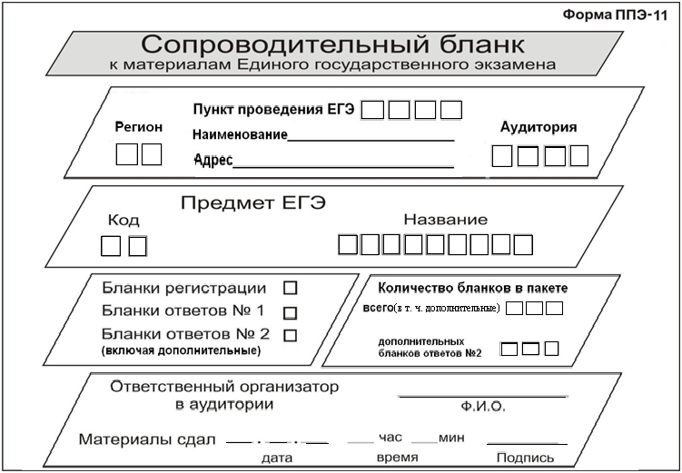

**ГИА**

ГИА

**ГИА**

**ГИА**